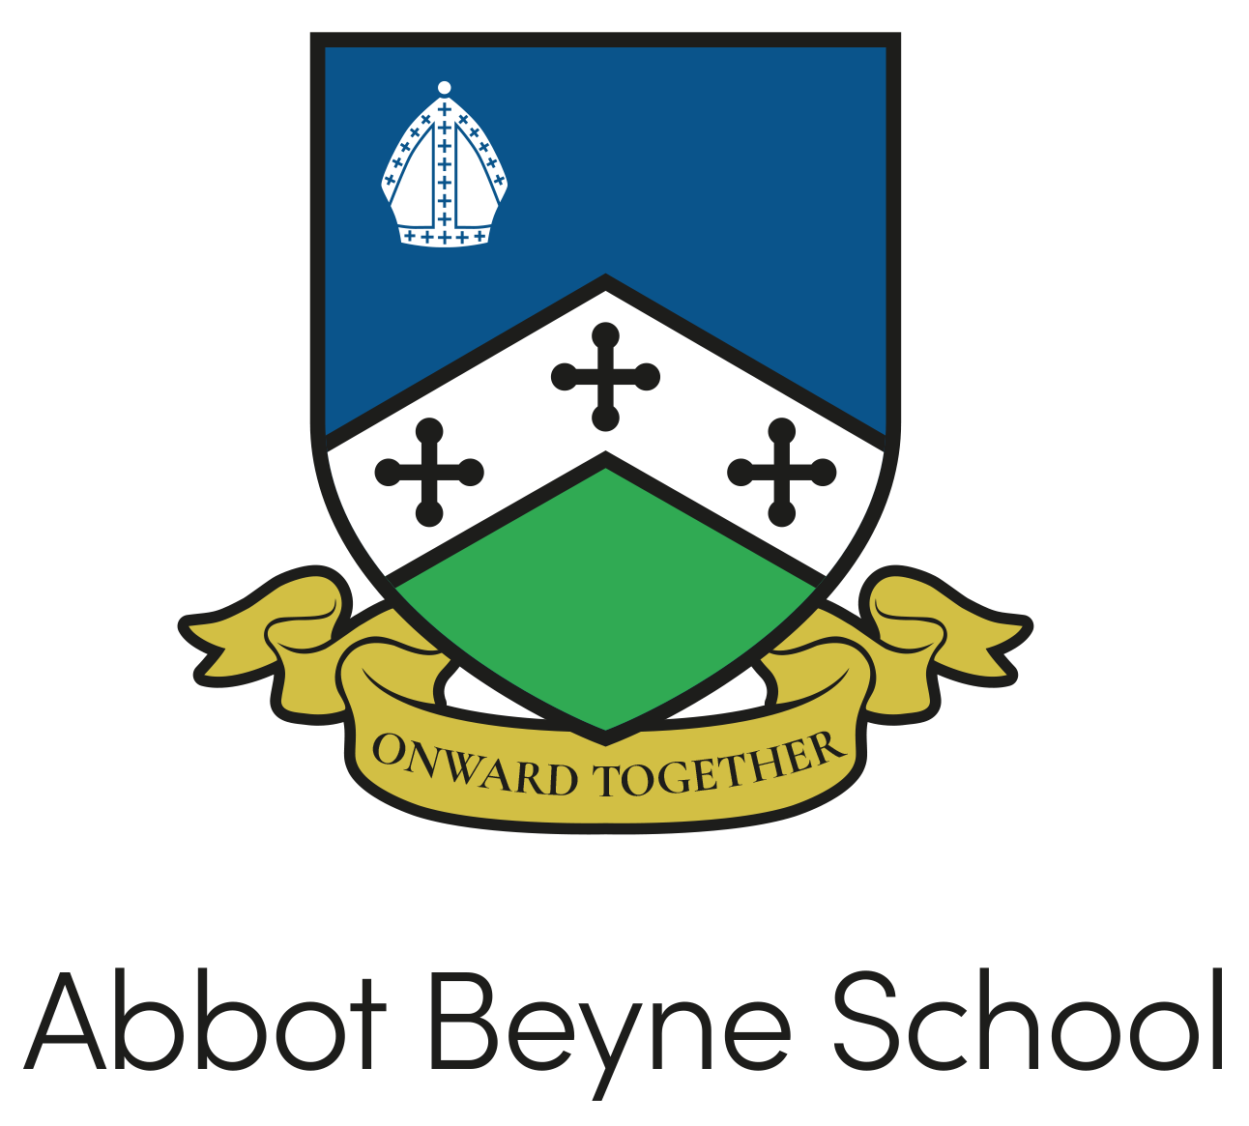

Policy: | Code of Conduct for Employees in School
Person Responsible: | Mr J Tickle
Governors’ Committee: | Full Governor Board
Adopted: | June 2014
Revised Date: | May 2023
Next Review Date: | May 2024
Signature:
Agreed by Staff:

Code of Conduct Policy

The Governing Board is required to set out a Code of Conduct for all school employees and volunteers.

In addition to this policy, all staff employed under Teachers’ Terms and Conditions of Employment have a statutory obligation to adhere to the ‘Teachers’ Standards 2012’ and in relation to this policy, Part 2 of the Teachers’ Standards - Personal and Professional Conduct.

Employees should be aware that a failure to comply with the following Code of Conduct could result in disciplinary action including dismissal.

PURPOSE, SCOPE AND PRINCIPLES

A Code of Conduct is designed to give clear guidance on the standards of behaviour all school staff are expected to observe, and the school should notify staff of this code and the expectations therein. School staff are role models and are in a unique position of influence and must adhere to behaviour that sets a good example to all the students within the school. As a member of a school community, each employee has an individual responsibility to maintain their reputation and the reputation of the school, whether inside or outside working hours.

This Code of Conduct applies to:

- all staff who are employed by the school, including the Headteacher;
- all staff in units or bases that are attached to the school.

The Code of Conduct does not apply to:

- peripatetic staff who are centrally employed by the LA;
- employees of external contractors and providers of services. (Such staff are covered by the relevant Code of Conduct of their employing body)

Staff Behaviour Policy/Code of Conduct for Schools/Academies

1. INTRODUCTION

1.1 All employees (and volunteers) should be aware of the standards of conduct expected of them by their employer. Although it is impossible to lay down rules to cover all eventualities, this Code sets out the key areas where concerns are likely to arise and staff awareness is necessary. The Code applies to all staff working in Abbot Beyne School. Staff should conduct themselves professionally at all times, particularly when communicating with students, parents, colleagues and external agencies in line with the values and ethos of Abbot Beyne School.

1.2 Staff must comply with requirements of their contract of employment, conditions of service, Articles of Governance, national professional standards and relevant local/national policies. The Code is supplementary to documents detailing terms and conditions of employment, including statutory provisions, relating to employment.

1.3 Failure to observe the provisions of the Code of Conduct may be relevant in considering action under disciplinary procedures. Should this occur, full consideration will be given to all the relevant facts and circumstances of the case in accordance with the principles of natural justice and following agreed procedures, in line with Abbot Beyne School Disciplinary Policy.

2. CONDUCT IN RELATION TO STUDENTS

2.1 Schools based staff act in loco parentis in respect of students in their charge as set out in the Children’s Act of 1989 and must act in the role of a reasonable parent in the school context. Through their actions staff must act in accordance with this duty of care to ensure at all times that the safety and welfare of students is accorded the highest priority. In this and other ways staff should always maintain standards of conduct which sustain their professional standing and that of Abbot Beyne School.

2.2 Interaction with students should always be appropriate to their age and gender. Staff should not touch students, however casually, in ways or on parts of the body that might be considered indecent, unnecessary or familiar and must not use inappropriate language. Particular care may be necessary when supervising students who are particularly vulnerable, and when engaged in out-of-school activities with any students. Staff should not engage with students via personal social media accounts, including Sixth Form and any ex-students under the age of 18 & must comply with ICT acceptable use policy.

2.3 Teaching materials should be appropriate to the age and gender of students. Particular care should be taken that sex or health education materials are appropriate and are consistent with Abbot Beyne School/Local Safeguarding Board policies.

2.4 When holding meetings with students on sensitive issues, staff should exercise proper professional judgement over the arrangements for the meeting. They should safeguard their own position by, for instance, considering the need for a second adult to be present.

2.5 Corporal punishment, defined as any intentional application of force as punishment, is illegal and may render a member of staff liable to criminal action as well as action under Abbot Beyne School disciplinary procedures. Corporal punishment includes any form of physical chastisement.

2.6 Physical intervention will not constitute corporal punishment where its purpose is to avert an immediate danger of injury to, or an immediate danger to the property of, any person including a student. In such circumstances, the element of restraint should be the minimum necessary to prevent injury or remove the risk of harm, in accordance with school policy.

2.7 Where physical contact is necessary (e.g. in teaching PE), that contact should be the minimum necessary for the purpose and any contact must comply with accepted good practice. Particular care should be taken in helping students with physical or other disabilities (e.g. in lifting). Further guidance is available in Codes of Practice produced by the professional associations and from the Local Authority representing staff in these subject areas.

2.8 Each school should have and follow a policy on first aid and have sufficient members of staff appropriately trained in its application, and in any event must always have a first aider on the premises. The policy should indicate the recording process for any incidents or accidents and should be clearly linked to the Health and Safety Policy.

2.9 Following any incident where a member of staff has reason to believe that their actions may be open to misinterpretation, the Headteacher should be immediately notified and a written report submitted as soon as possible following the incident. Heads should follow Safeguarding Board guidance and contact a LADO where necessary.

2.10 Guidance on procedures regarding suspected or alleged child abuse is contained in the Local Safeguarding Children Board procedures (Safeguarding Policy). Abbot Beyne School has designated responsibility for child protection. In the event that a member of staff suspects or receives allegations that a child is the subject of abuse, a report should immediately be made in strict confidence to the designated teacher who will immediately inform the First Response service.

2.11 Agreed guidelines on procedures where staff are accused of physical or sexual abuse of students are contained in the Abbot Beyne School Safeguarding Policy.

2.12 It is the responsibility of all members of staff working in Abbot Beyne School to ensure that they are up to date on all relevant policies and procedures.

3. CONDUCT IN RELATION TO ABBOT BEYNE SCHOOL

3.1 Staff should make sure that they do not disclose confidential information to anyone who has no right to receive it and that they do not say or write anything that would constitute a breach of confidence. Confidential information relating to employment or Abbot Beyne School should only be communicated on a need to know basis or with the specific prior permission of the Head. Please see the Data Protection and E-Safety Policy for guidance about confidentiality and the use of social media.

3.2 Use of materials and equipment provided by Abbot Beyne School should not be used for purposes unconnected with employment. Staff should always use public funds and resources to the best advantage of the students and community.

3.3 Abbot Beyne School has a Code of Conduct which describes the requirement to report to the Headteacher or other relevant person any indirect or direct financial interest in any contract or other matter involving the Council or Abbot Beyne School. This is particularly relevant in cases of tendering or in the selling of surplus equipment or property. Headteachers should disclose such interest to the Chair of Governors or in case of doubt to a senior officer of the Local Authority.

3.4 Staff should not solicit or accept any gift, loan, fee, hospitality or other reward which influences the way in which they carry out their duties. They should not influence or be influenced unfairly in the way they carry out their duties by ties of kinship or friendship, or by any other association or loyalty.

3.5 Care should be taken to avoid any conflict of interest between activities outside Abbot Beyne School and professional responsibilities. Staff should not undertake work or engage in activities in their own time through which they seek to exercise unfair advantage by virtue of their position. In no case should outside activities be of a nature that they may bring Abbot Beyne School into disrepute.

3.6 Staff should not, without authority or prior approval, undertake activities unconnected with their professional role during working hours. Policies relating to Absence should be followed.

3.7 Staff in full-time employment should inform their Headteacher where they are undertaking other paid work which may impinge on their normal duties, including activities such as lectures, private tuition, publications, press articles or radio/TV appearances. Where work is undertaken in the employee’s own time any fees paid may be retained by the employee. However, where the event, or preparation for it, takes place in working time and/or involves the use of Abbot Beyne School resources, it is necessary to seek approval do so or to use such resources and the employee and Abbot Beyne School must agree the proportion of any fee to be paid to Abbot Beyne School for such use.

3.8 The payment of fees to teachers acting as examiners or moderators is covered by the specific provisions of the Burgundy Book and the regulations of Examining Bodies.

3.9 In addition to financial interests, staff should exercise professional judgement when considering the need to disclose to the Headteacher or their line manager, non-financial interests which may conflict with the interests of Abbot Beyne School or the LA. Such disclosure will depend upon circumstances (e.g. in making recruitment decisions) and may include personal acquaintances, membership of voluntary or other organisations or any other official position or public appointment.

4. 7 PRINCIPLES OF PUBLIC LIFE

4.1 All staff should abide by the 7 principles of public life (the ‘Nolan principles’) –
https://www.gov.uk/government/publications/the-7-principles-of-public-life/

4.2 All staff should exercise good judgement when using social media (any form of online public interaction with others), ensuring that they do not make negative comments regarding their employer, students or parties connected with their employment. In particular, staff must not post material that could be considered obscene, threatening, intimidating, or discriminatory or which could bring their employer into disrepute.

