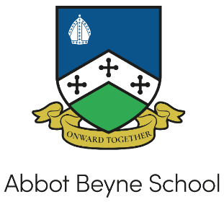
Why work at Abbot Beyne School?

I am really pleased that you are considering becoming a member of Abbot Beyne School. As we move “Onward Together” we are looking for staff who wish to join our vibrant school and make a real difference to our community. We are an 11-18 Secondary School and Sixth Form serving the Winshill community and surrounding areas. We are an inclusive and aspirational school, focussed on delivering high quality learning and teaching in a safe and nurturing environment. We are committed to ensuring the academic success and well-being of all of our students at the same time as insisting on the highest standards of behaviour. We offer a broad, balanced and ambitious curriculum alongside a significant number of enrichment opportunities.

‘Everyone a Learner. Everyone Learning.’ This is at the heart of our message to staff, students, governors, parents and carers. We want to develop a love of learning to ensure students become life-long, reflective learners. Our values are held by all members of our school community; Respectful, Responsible and Resilient. We expect all staff and students to uphold these values at all times.

We are an Apple Distinguished Status School. Apple Distinguished Schools are centres of leadership and educational excellence that demonstrate Apple’s vision for learning and technology – and we believe they are some of the most innovative schools in the world (Apple). All staff and students have their own iPad, ensuring work is personalised and challenging, breaking down barriers between home and school learning.

Staff workload and wellbeing are high on our list of school priorities. To support staff wellbeing we offer:

- The Staff Wellbeing Charter, holding ourselves accountable to the principles defined in here
- A good work / life balance and a communications policy to support this
- A school assessment policy removing the need to mark homework at Key Stage 3 and utilising voice recordings to significantly reduce workload
- A new Management Information System to ensure information is together in one place
- A new behaviour policy to support teachers in the classroom and ensure there is a calm, orderly manner around the school
- An open door policy and termly staff surveys to improve staff workload and wellbeing
- PPA can be taken at home
- A personalised CPD programme to ensure staff are supported in their own career aims
- A coaching programme
- The cycle to work scheme
- All staff have their own laptop and / or iPad

At Abbot Beyne School we are much more than exam grades. We are interested in the whole child. To that end all staff are involved in some form of enrichment / extra-curricular activity to help develop relationships with students and develop a greater sense of pride at the school.

Working at a school, and in teaching, is an incredibly rewarding experience yet is equally challenging. If you think Abbot Beyne School might be a place that you wish to come and work, please contact office@abbotbeyne.staffs.sch.uk to view this wonderful school.

